Bahria University, Lahore Campus
Department of Computer Science | BSCS-5 | Artificial Intelligence
UAV Strategy Engine
Multi-Objective Genetic Algorithm for Drone Deployment, Trajectory and Sensor Scheduling
Assignment 2 (CLO-4) – Brief Technical Report
Name : Muhammad Ibrahim Sajjad Roll No : 03-134242-042

1. Problem and Approach
A disaster-management company operates a fleet of UAVs over a volatile hazard grid. A mission plan must decide where each drone is deployed, which waypoints it flies, how fast it flies, and when its sensor is on and at what power. These decisions conflict: wide, slow, high-power sensing finds more targets but drains the battery, takes longer and exposes the drone to wind or radiation pockets. Because there is no single correct answer, we built a Strategy Engine around a Genetic Algorithm (GA) that searches this trade-off space with a custom chromosome, a multi-objective fitness function, spatially aware genetic operators and dynamic constraint handling.
The complete implementation is a modular, object-oriented Python repository (NumPy and Matplotlib only). Every number reported in this document was produced by running that code; the figures and terminal screenshots are the project’s own output.

2. System Design

2.1 Simulation environment
The mission space is a 50 × 50 grid of cells (the “hazard grid”). It is generated from a fixed seed so every experiment uses the same map (Figure 1). The settings are listed in Table 1.
Element | Description
Priority map | Four Gaussian disaster zones, values 0.05–1.0; coverage of a cell is worth its priority.
Hazard map | Five wind/radiation pockets (values 0–1); two are deliberately placed on top of priority zones so that value and risk conflict.
No-fly zones | Four rectangular blocked regions (boolean cells), kept away from the base.
Targets | 30 hidden targets, more likely in high-priority cells; weighted by local priority.
Fleet | 4 drones, launched from and recovered at a base station at the bottom-left corner.
Hard limits (per drone) | Path length ≤ 190 cells, energy ≤ 650 units, flight time ≤ 110 s, no flight through no-fly cells.
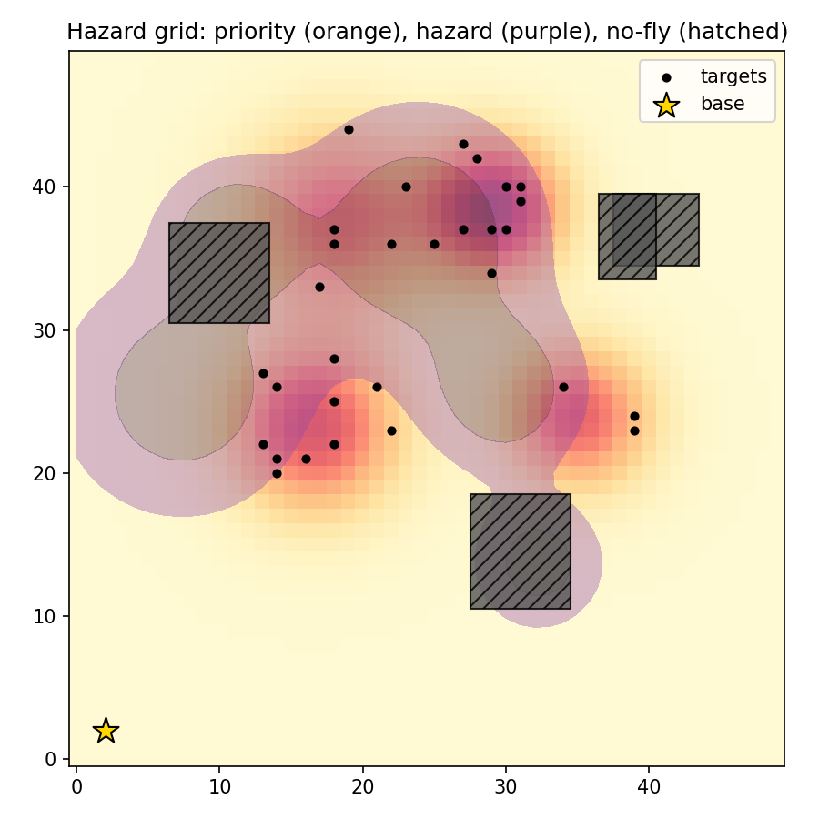

2.2 Chromosome representation and rationale
A chromosome is a real/binary hybrid array of shape (drones × waypoints × 5 genes) = 4 × 8 × 5. Each drone owns one segment of the chromosome, and each waypoint carries five genes (Table 2). Waypoint 0 of every drone is its deployment (staging) position; the drone flies base → waypoints in order → base.
Gene | Meaning | Type / range | Why it is encoded
x, y | Waypoint position | Real, [0, 49] | Encodes deployment position and trajectory directly in grid space, so spatial operators are meaningful.
v | Speed on the leg into the waypoint | Real, [1, 5] cells/s | Lets the GA trade time against energy (drag ∝ v²) and sensor quality.
p | Sensor power | Real, [0, 1] | Sets sensing radius 1.5–6 cells; energy cost grows as p².
a | Sensor ON/OFF bit | Binary {0, 1} | Sensor activation schedule: sensing only where it pays off saves energy.
Table 2. Gene layout of one waypoint.
We chose a per-drone, per-waypoint layout instead of one flat vector because the unit that matters in this problem is a drone’s route. Keeping a drone’s genes contiguous lets crossover exchange whole routes or route fragments without breaking them, while the binary schedule bit fits naturally with the real-valued genes in the same waypoint. (Code screenshots are given in Appendix A, Figures A4–A6.) A repair operator keeps every individual valid: coordinates and speeds are clipped to bounds, the schedule bit is binarised, and any waypoint inside a no-fly zone is moved to the nearest free cell.

2.3 Multi-objective fitness function and weights
Each chromosome is executed in a mission simulator. Every leg is sampled once per cell to measure hazard exposure and no-fly crossings. While a sensor is on, a disc of the current sensing radius is stamped along the leg, building a coverage map and detecting targets. The fitness to maximise is:
F = 0.30·Coverage + 0.25·Detection − 0.15·Energy − 0.10·Time − 0.20·Hazard − Penalty
Coverage is the priority-weighted fraction of cells sensed and Detection is the priority-weighted fraction of targets found. Energy is the fleet’s total of L·(1.0 + 0.12·v²) plus sensor energy 1.5·p²·t, divided by total battery; Time is the slowest drone’s flight time divided by the deadline; Hazard is the integral of hazard intensity along all paths, normalised by total range. All terms are scaled to roughly [0, 1], so the weights express priorities directly.
The weights put 55 % of the positive mass on mission value (coverage and detection) and 45 % on the three costs. Hazard is weighted above energy and time because exposure risks losing the aircraft, whereas energy and time are already bounded by hard constraints. The speed-dependent sensor blur (up to 35 % smaller radius at top speed) makes the objectives genuinely conflict: flying fast saves time but sees less and burns more energy.

2.4 Constraint handling
Four hard constraints (range, battery, deadline, no-fly) are handled by two cooperating mechanisms. Repair fixes what can be fixed cheaply (bounds and waypoints inside no-fly cells). Dynamic penalties punish the remainder: each violation is normalised, multiplied by its constraint weight (3 for range, battery and time; 4 for no-fly), and scaled by a factor that ramps linearly from 1.0 to 3.0 during the run. Early generations can therefore explore slightly infeasible regions that may lead to good solutions, while late generations are pushed firmly into the feasible region. The best individual is re-scored at the strictest penalty before being returned.

2.5 Genetic operators and diversity maintenance
- Selection: tournament selection (size 3 by default; the tournament size is the selection pressure) or rank-based roulette, plus 2-individual elitism.
- Crossover (one of three chosen per mating, 30/40/30 %): route swap (exchange whole drone routes), segment swap (exchange a contiguous run of waypoints inside a drone’s route) and geometric blend (arithmetic blend of continuous genes with uniform crossover on the schedule bits).
- Mutation: Gaussian jitter of coordinates with a step that shrinks from 6 to 2.4 cells over the run; priority-biased waypoint reset (a long jump to a high-value location); Gaussian tweaks to speed and power; schedule bit-flips; and route-order mutation (reverse or swap waypoints, 2-opt style).
- Diversity control: population diversity is measured as the spread of waypoint coordinates relative to a uniformly random population. When it falls below 0.30 the mutation rate is raised by 30 % (up to 0.5) and 10 % of the population is replaced by random immigrants, which helps to avoid premature convergence.
- Termination: maximum number of generations, or no improvement for a patience window (40 generations).

3. Results of the Final Evolved Solution
The default run (population 60, 100 generations, seed 0, 6,120 fitness evaluations, runtime about 17 s) is shown in Appendix Figure A1. Table 3 summarises the evolved plan against the best random-search plan found with the same budget; the two flight-path maps are shown side by side in Appendix Figure A3.
Metric | Genetic Algorithm | Best random search | Better is
Final fitness | +0.365 | −6.560 | higher
Priority coverage | 82.7 % | 75.0 % | higher
Target detection | 100 % | 97.5 % | higher
Total energy | 1,091 | 1,908 | lower
Mission time (slowest drone) | 47.3 s | 130.5 s | lower
Hazard exposure | 102.9 | 187.9 | lower
Hard constraints satisfied? | Yes (violation 0) | No (violation 0.75) | –
Table 3. Evolved GA solution vs. best random-search solution (equal evaluation budget).
The convergence curves (Figure 2) show the typical GA pattern. The best fitness climbs from −12.7 in generation 0 (no feasible individual yet) to +0.25 by generation 10 and +0.365 by generation 80. The fraction of feasible individuals rises from 0 to about 70 %. The average fitness stays well below the best because the population still contains infeasible offspring that are penalised heavily; this is intentional, as these individuals keep exploration alive. Population diversity falls from 0.97 to about 0.32, so the search converges without collapsing. The random-search curve improves only in rare jumps and ends far below the GA.
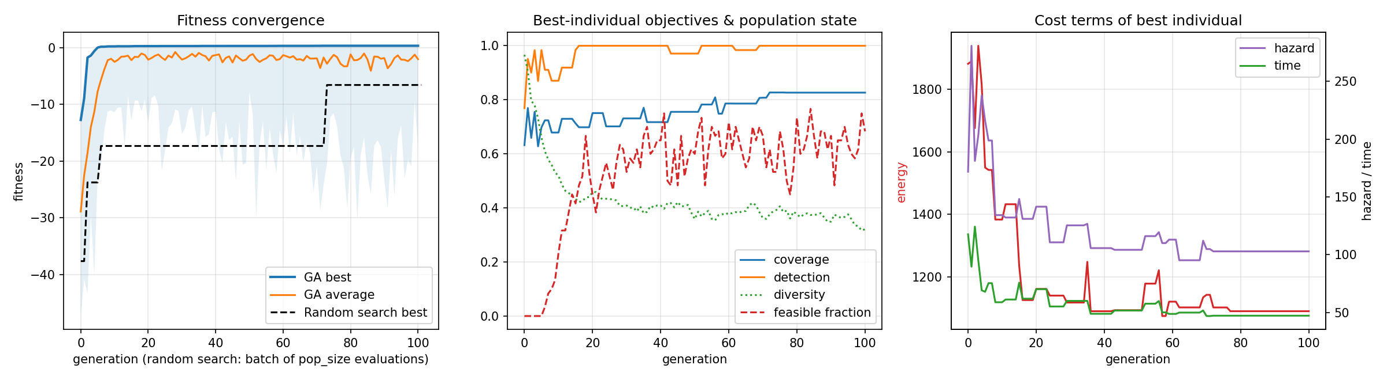

Figure 3 shows how the best flight plan and its coverage heatmap change over generations. In generation 0 the routes are long, crossing and often cover empty areas, and several targets are missed (red crosses). By generation 33 the drones concentrate on the priority zones; by generation 100 the routes are short, fan out from the base, switch sensors off on the transit legs (hollow dots) and keep outside the no-fly rectangles. The heatmaps show the coverage count moving from diffuse stripes into the high-priority regions (red contours).
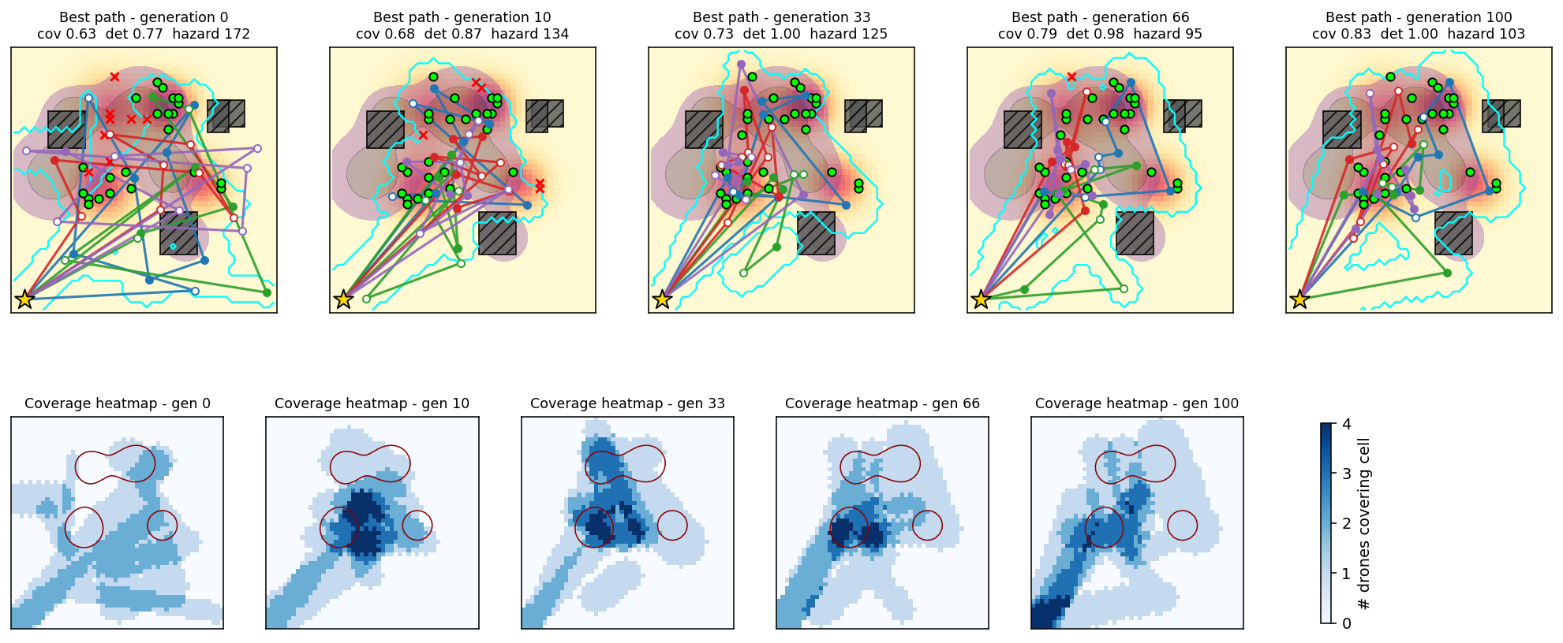

4. Hyperparameter Sensitivity Analysis
We varied population size, mutation rate and selection pressure (tournament size) one at a time, with the other parameters at the baseline (population 40, mutation rate 0.12, tournament size 3). Each setting was run for 50 generations with 3 seeds; Table 4 reports the mean ± standard deviation of the final best fitness.
Parameter | Value | Final fitness | Coverage | Feasible | Diversity
Population size | 20 | 0.315 ± 0.005 | 0.747 | 100 % | 0.38
 | 40 | 0.320 ± 0.009 | 0.767 | 100 % | 0.38
 | 80 | 0.344 ± 0.003 | 0.776 | 100 % | 0.39
Mutation rate | 0.01 | 0.351 ± 0.003 | 0.814 | 100 % | 0.33
 | 0.05 | 0.343 ± 0.005 | 0.782 | 100 % | 0.32
 | 0.12 | 0.320 ± 0.009 | 0.767 | 100 % | 0.38
 | 0.30 | 0.289 ± 0.012 | 0.761 | 100 % | 0.48
Tournament size | 1 | 0.285 ± 0.009 | 0.698 | 100 % | 0.45
 | 2 | 0.315 ± 0.006 | 0.790 | 100 % | 0.39
 | 3 | 0.320 ± 0.009 | 0.767 | 100 % | 0.38
 | 6 | 0.347 ± 0.009 | 0.796 | 100 % | 0.31
Table 4. Sensitivity of final fitness (3 seeds, 50 generations).
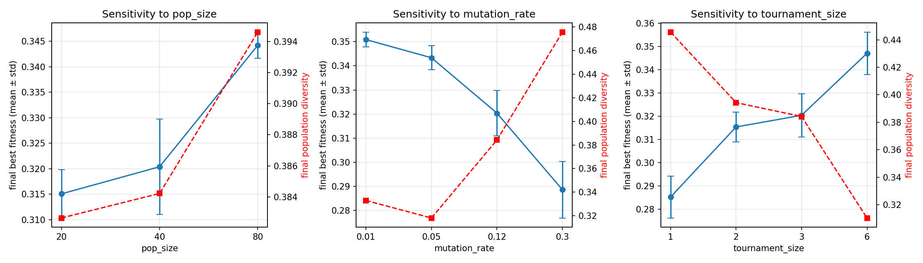
Figure 4. Final fitness (blue, left axis) and final population diversity (red dashed, right axis) versus each hyperparameter.
- Population size. Fitness improves monotonically (0.315 → 0.344) and the run-to-run spread shrinks with a larger population, because more individuals sample more of the 160-dimensional search space per generation. The cost is linear in evaluations, so population 80 needs four times the evaluations of 20.
- Mutation rate. Within 50 generations, lower rates did better (0.351 at 0.01 vs 0.289 at 0.30). High rates keep diversity high (0.48) but destroy good routes faster than selection can rebuild them, behaving like random search. With only 50 generations we cannot tell whether very low rates stall in longer runs; the adaptive boost and immigrants are meant to counter that. A rate around 0.01–0.05 is a good compromise for this problem; our default of 0.12 is more exploratory than necessary.
- Selection pressure. Tournament size 1 is equivalent to random mating and gives the worst result (0.285, coverage 0.70). Fitness rises steadily with pressure up to size 6 (0.347) while final diversity falls from 0.45 to 0.31. This is the usual exploration/exploitation trade-off; with our diversity safeguards active, higher pressure did not cause premature convergence.
These conclusions come from 3 seeds and 50 generations, so differences smaller than about 0.01 should be read with caution. Based on this study, a population of 80, mutation rate 0.05 and tournament size 5–6 would be the recommended configuration (command: python main.py --pop 80 --mut 0.05 --tournament 5).

5. Evolved Solution versus Random Search
Random search draws uniformly random chromosomes (the same sampler that creates the GA’s generation 0) and keeps the best, using exactly as many evaluations as the GA and scored with the same final penalty. We repeated both methods for 5 seeds (population 50, 70 generations).
Statistic (5 seeds) | GA | Random search
Mean final fitness ± std | +0.347 ± 0.012 | −18.44 ± 4.50
Runs that satisfy all hard constraints | 5 / 5 | 0 / 5
Coverage of high-priority core (priority > 0.5) | 99.5 % | 78.1 %
Mean pairwise Jaccard similarity of coverage maps across runs | 0.73 | 0.50
Welch t-statistic (GA vs RS fitness) | 8.4 | –

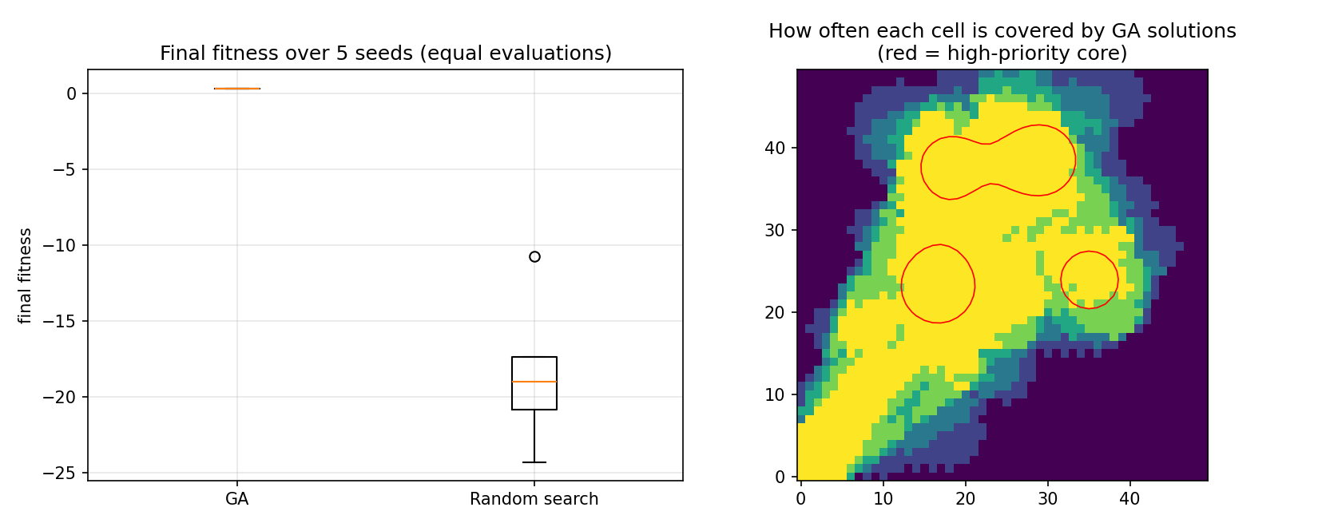

The evolved solution is qualitatively different from anything random sampling produces. Random search never found a feasible plan in 5 runs: with 160 coupled genes, the chance that all four drones simultaneously respect the range, battery and deadline limits while avoiding no-fly zones is very small. The GA found feasible plans in every run and also scored higher on the raw objective (before penalties): in the main run the random-search plan had a raw objective of 0.19 against 0.365 for the GA, because it covers less, flies longer paths and is more exposed to hazard (Table 3).
The GA’s solutions are also consistent rather than lucky. Their coverage maps overlap strongly across seeds (Jaccard 0.73 vs 0.50) and almost completely cover the high-priority core (99.5 % vs 78 %), whereas random-search plans differ from run to run. The overlap is still below 1, so the runs do not reproduce one identical plan: different seeds reach similar-quality but not identical route assignments, which is expected in a multi-objective landscape with many near-equivalent optima.

6. Conclusion
We designed and implemented a GA-based Strategy Engine for UAV disaster surveillance. Its hybrid chromosome captures positions, speeds and sensor schedules; its multi-objective fitness trades value against energy, time and hazard; custom spatial crossover and mutation operators, adaptive diversity control, repair and dynamic penalties make the search effective and constraint-aware. Over repeated runs the GA found feasible plans with about 83 % priority coverage and 100 % detection, while random search with the same budget found none. The sensitivity study shows that larger populations, stronger selection and moderate-to-low mutation rates work best for this problem.
Limitations. The environment is a single synthetic map; the sensor and energy models are simplified; results use few seeds (3–5) because runs were executed on a single CPU core; and the objectives are combined with fixed weights rather than a Pareto front (a natural extension would be NSGA-II).

Appendix A. Repository Structure and Reproduction
The code is organised as a modular Python package. To reproduce all results:
pip install -r requirements.txt | python main.py | python compare_baseline.py | python sensitivity.py
